**Introduction**

**What is Azure SQL Database?**

Azure SQL Database is a fully managed platform as a service (PaaS) database engine that handles most of the database management functions such as upgrading, patching, backups, and monitoring without user involvement.

Azure SQL Database is always running on the latest stable version of the SQL Server database engine and patched OS with 99.99% availability.

PaaS capabilities that are built into Azure SQL Database enable you to focus on the domain-specific database administration and optimization activities that are critical for your business.

With Azure SQL Database, you can create a highly available and high-performance data storage layer for the applications and solutions in Azure.

SQL Database can be the right choice for a variety of modern cloud applications because it enables you to process both relational data and non-relational structures, such as graphs, JSON, spatial, and XML.

**Architecture Diagram**

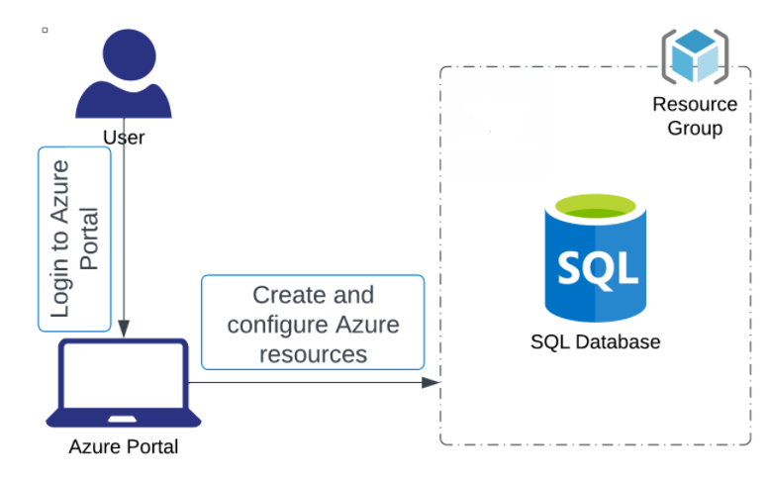

# ****Lab Steps****

## ****Task 1: Sign in to Azure Portal****

## ****Task 2: Create a Azure SQL Database****

1. On the Azure portal menu or from the Home page, select **Create a resource**.



1. On the New page, select **Databases** in the **Azure Marketplace** section, and then click **SQL Database** in the Featured section.

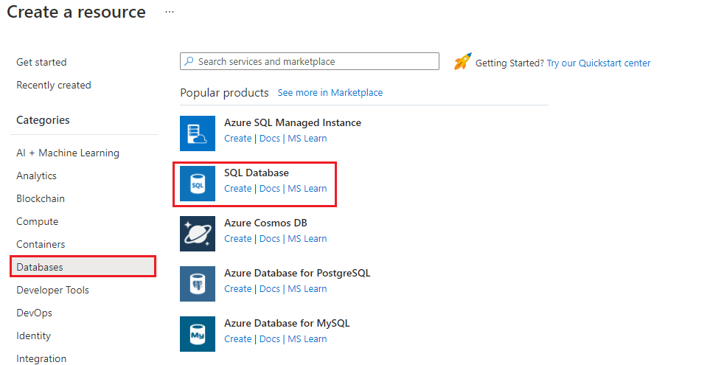

1. Fill out the **SQL Database** form with the following information

* Resource group: Select **rg_eastus_XXXXX**
* Database name: Enter ***WhizDatabase***
* Server: Click on **create new**
  + Server name: Enter a unique name
  + Location: Select **East US**
  + Authentication method: Select **Use SQL authentication**
  + Server admin login: Enter **WhizAdmin**
  + Password: Enter a password
  + Confirm password: Re-enter the password
  + Click on **OK**
* Server: Select the newly created server
* Want to use SQL elastic pool : Select **No**
* Compute + Storage : Select **Configure database**
  + Service tier : Select **Basic (For less demanding workloads)**
  + Click on **Apply**
* Backup storage redundancy: Select **Locally-redundant backup storage**

*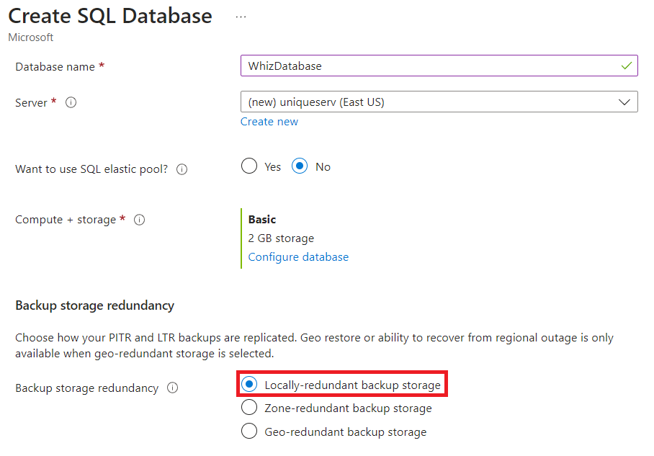  
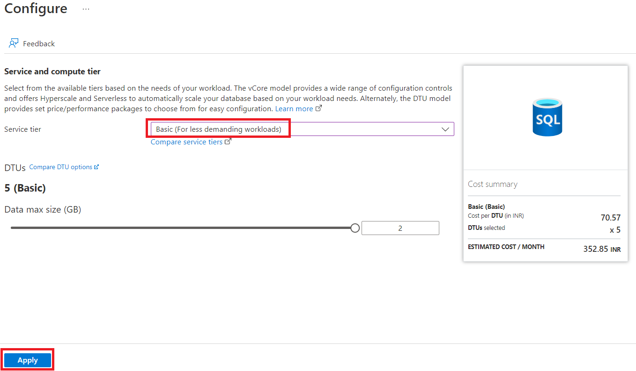*

1. Now click on **Next: Networking** and update the connectivity method to public endpoint.

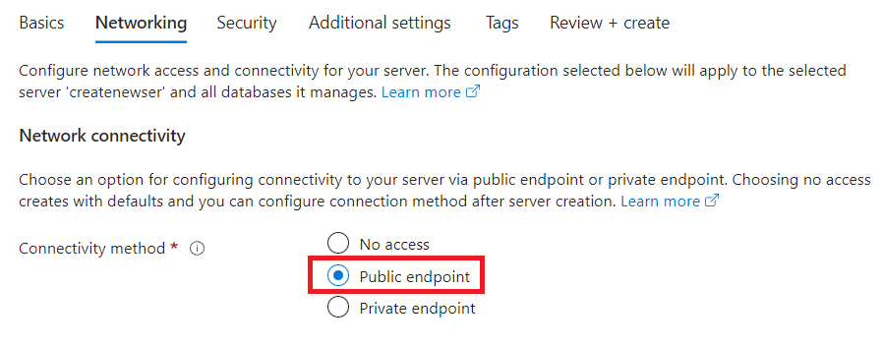

1. Click **Review + Create** and then click on **Create** to provision the database. This step may take a few minutes.

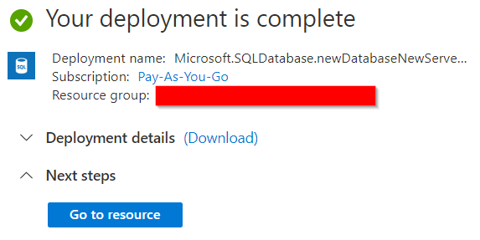

**Task 3: Create a server-level IP firewall rule**

1. After the deployment completes, select **SQL databases** from the Azure portal menu or search for and select **SQL databases** from the page.
2. Select **WhizDatabase** on the SQL databases page. The overview page for your database opens, showing you the fully qualified **Server name** (such as **whizlabserver01.database.windows.net**) and provides options for further configuration.

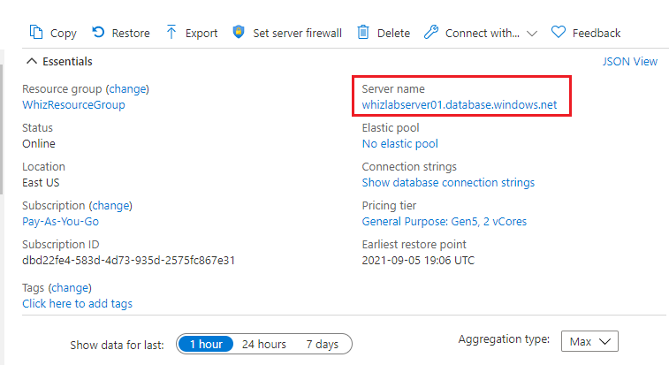

1. Click on the server name and it will redirect you to the **whizserver** you created. On the left side panel, select **Networking**. Then under **Public network access**, select **Selected networks**.

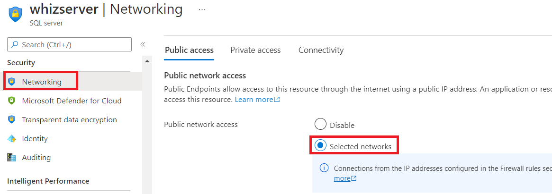

1. Under, Firewall rules, click **+ Add your client IPv4 address** on the toolbar to add your current IP address to a new IP firewall rule. An IP firewall rule can open port 1433 for a single IP address or a range of IP addresses. Scroll down and check the box for **Allow Azure services and resources to access this server**

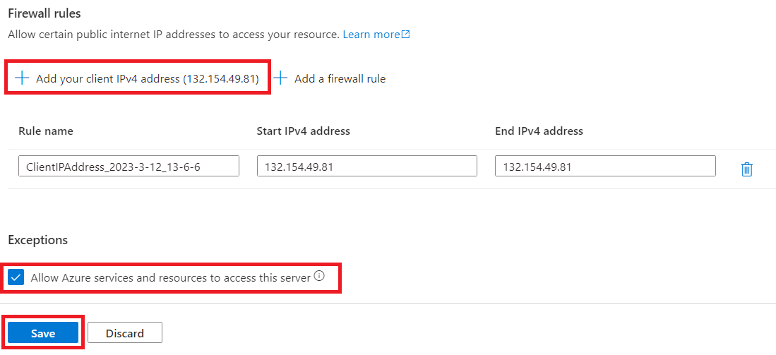

1. Click **Save**. A server-level IP firewall rule is created for your current IP address opening port 1433 on the server.

## ****Task 4: Connect to the database****

1. Go back to SQL database and click on **Query editor** from left hand side menu bar

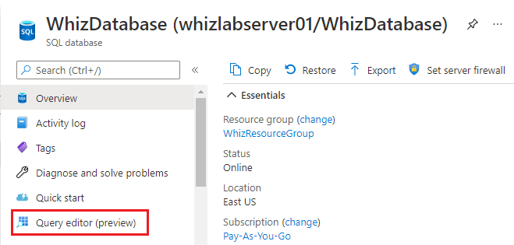

1. Enter the password you created for the SQL admin server in the box and then click on **OK.**

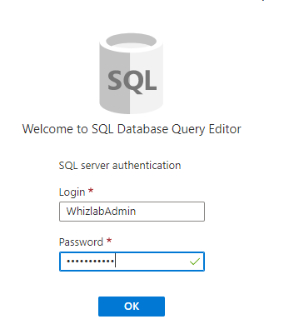

## ****Task 5: Create tables in the database****

In the query window, paste the following query to create four tables in your database and then click on **run.** You will get the **Query succeeded** message.

-- Create Person table

CREATE TABLE person

(

personid INT IDENTITY PRIMARY KEY,

firstname NVARCHAR(128) NOT NULL,

middelinitial NVARCHAR(10),

lastname NVARCHAR(128) NOT NULL,

dateofbirth DATE NOT NULL

)

-- Create Student table

CREATE TABLE student

(

studentid INT IDENTITY PRIMARY KEY,

personid INT REFERENCES person (personid),

email NVARCHAR(256)

)

-- Create Course table

CREATE TABLE course

(

courseid INT IDENTITY PRIMARY KEY,

NAME NVARCHAR(50) NOT NULL,

teacher NVARCHAR(256) NOT NULL

)

-- Create Credit table

CREATE TABLE credit

(

studentid INT REFERENCES student (studentid),

courseid INT REFERENCES course (courseid),

grade DECIMAL(5, 2) CHECK (grade <= 100.00),

attempt TINYINT,

CONSTRAINT [UQ_studentgrades] UNIQUE CLUSTERED ( studentid, courseid, grade, attempt )

)

Click on the **Tables** tab to view the all the four table that you created.



### ****Do you know ?****

**With Azure SQL Database, you can easily scale your database resources up or down based on demand, pay only for the resources you consume, and benefit from the global availability and resilience of the Azure cloud infrastructure.**